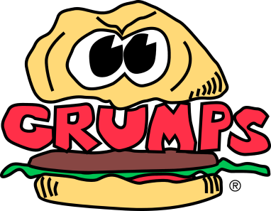
Fryer Station Closing Procedures
- Clean and filter fryer
  - Add oil if necessary
  - Change Oil when test kit results are within range
  - Initial & date Oil Change Log
  - Wipe down fryer (Inside and Out)
- Clean Fryolator
- Turn off water and roll up hose. (In Winter, bring hose inside)

- Clean Tables and Shelves
Change out cardboard under table

- Rotate and stock pans of Pickles, Jalapenos and onions in clean containers and put in refrigerator

- Top off fry batter container with fresh/recycled fry batter & put top on batter container

- Clean microwave (IN and OUT)

- Clean wall behind and next to fryer

- Refill Fried items in chest freezer (Defrost Freezer on Saturday)

- Restock fry boats

- Sweep kitchen, Walk-in Refrigerator and Freezer, move Chest Freezer , Kitchen cart and Sandwich board and sweep
- Place an empty box next to fryer for waste
- Perform any other duties as directed by manager on duty

