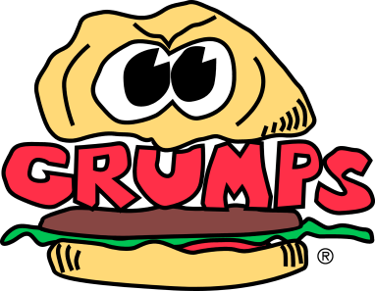

Grill Station (2nd Cut) Mid-Day Procedures

- Restock Margarine, Grilled Onions, Green Chile’s and Mushrooms

- Refill Shakers

- Check Par Lists to ensure Correct Par Levels are Maintained (Includes Queso)

- Cook all food for tickets in timely manner

- Restock large buns, junior buns, jalapeno buns and Texas toast on rack

- Check trash cans in kitchen and dining rooms, replace if necessary

- Perform other duties as assigned by manager on duty

