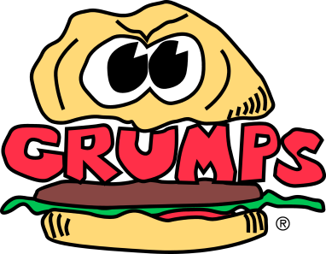
Sandwich Board Opening Procedures
Grill Set Up:
- Fill shakers with appropriate seasonings and place in appropriate places
- Melt left over margarine in butter pan(s)
- Add additional block(s) of margarine for appropriate days business
- See “Kitchen Prep Procedures”
- Retrieve raw onion parts for “Grilled Onions” from walk in.
- Place onion parts, melted margarine and Grumps seasoning on hot grill to begin grilling (If there are any unused raw onions left, return to walk in stored in appropriate labeled container)
- Retrieve raw mushrooms from walk in
- Place raw mushrooms, melted butter, and Grumps seasoning on hot grill to begin grilling (If there are any unused raw mushrooms left, return to walk in stored in appropriate labeled container)
- Once Grilled Onions and Grilled Mushrooms have finished cooking, remove from grill and place in bain- maries.
- Retrieve green chile’s from walk in or sandwich board (Note: there could be left over green chile’s from previous day business, if so, use these first)
- Place green chile’s in bain- maries on grill

Sandwich Board Set Up:
- Remove lids from hotel pans in top of sandwich board
- Remove food service film from patty tub, patty tray and chicken container
- Fill sanitizer buckets with appropriate solution and place in designated areas (See MOD)
- Retrieve kitchen knife and put in sanitizer bucket under kitchen cart
- Assist with any food prep that is required (See MOD)
- Throw away all trash accumulated during set up procedures
- Take all dirty dishes, lids, trays, utensils, etc, to wash sink area
- Clean up any mess made during Grill Set Up and/or Sandwich Board Set Up
- Perform any other duties as assigned by the Manager on Duty

