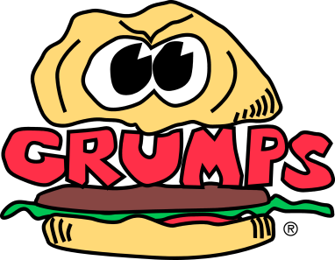
Grill Station Cook
Title: Cook
Reports to: Manager on Duty

Duties and Responsibilities:
- Prepares items on Grumps Menu for cooking on flat top, fryer, and other kitchen equipment
- Assumes 100% responsibility for quality of products served
- Knows and complies consistently with Grumps’ standard portion sizes, cooking methods, quality standards and kitchen rules, policies and procedures
- Stocks and maintains sufficient levels product in kitchen area to assure satisfactory ticket times
- Portions Meat patties prior to cooking according to Grumps’ Portion Size Chart and Grumps’ recipe specifications
- Maintains a clean and sanitary work area including tables, shelves, grills, fryers, sandwich board and refrigeration equipment
- Prepares items for grilling, frying or other cooking methods
- Handles, stores and rotates all products properly
- Assists in all food prep
- Keep area clean
- Wash hands regularly
- Adhere to TFER guidelines for personal hygiene and food safety
- May have to lift up to 100 pounds
- Performs other related duties as assigned by Manager On Duty

