CASHIER TRAINING

Day One:
Classroom: 10:00AM-10:30AM & POS Training: 10:30AM-11:00AM OR
Classroom: 3:00PM-3:30PM & POS Training: 3:30PM-4:00PM
ON THE JOB TRAINING
- Your job today is for your trainee to watch you. Your trainee shouldn’t be doing anything hands on today unless they are accelerated and pick up on it quicker. Their job is to watch and to listen. They should be listening to the questions you are asking and watching to see how you handle everything. (Making shakes, pouring beer, answering the phone, etc.)
- 5 FOOT RULE:
  - You should never leave your trainee. The 2 of you should never be more than 5 feet apart. If you go to clean something (drink station, bathroom) or wash dishes (whatever the case may be) take your trainee with you.
  - They are not going to learn anything if you leave them.
- This is the perfect time to see if your trainee has any questions. Day 1 should be very simple for the trainee.

- POS TRAINING- This is a very brief overview of the POS system.

- **If there is any downtime throughout the shift, be sure to show the trainee how to read kitchen chits. This could be through putting togo orders together or just grabbing the kitchen chits that have already been delivered and going over what is on them. **

- Our Story
  - Fresh never frozen, hand pressed patties
  - Fresh Produce
  - Homemade Ranch Dressing
  - Homemade Roasted Ranch Dressing
  - Award Winning Jalapeno Ketchup
  - Mucho Beer Frio
- Grumps History:
  - We opened our doors in Granbury in 2002
  - Based on simplicity
    - 2 proteins- Burgers and Chicken
  - 1 POS to control the flow of the line
  - Items cooked to order
  - Our Goal is to serve Good Product, at a good value and serve with Texas Hospitality
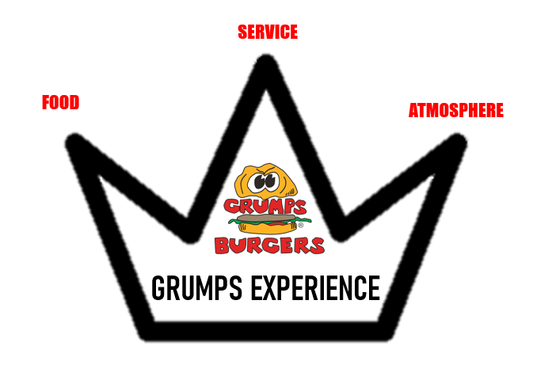
- Food – 5 layer approach
  - Taste
  - Temperature
  - Presentation
  - Portion
  - Value

- Service – at the least, the customer should feel appreciated, ideally, special
  - Appreciated – Simple stuff – “hi’s &amp; bye’s, thank you” “Y’all come back now, ya hear,”
  - Special – name recognition, food/drink recognition, specific table touch to check on,
  - “Shock &amp; awe” moments, Fall on the sword (opportunities) – We will make mistakes, admit and make right.
  - Texas Hospitality- Kind, genuine, courteous

- Atmosphere – anyone can hang a cool picture on a wall, but wait, there’s more!!!
  - Cleanliness - #1 Restrooms! Important and need constant quality checks. -If your food/service/atmosphere are terrific on a particular customer visit BUT the restroom is umm messy, that’s what the customer will remember and your hard work is forgotten. Turd in the toilet…
  - Temperature – settings are for the customer’s experience, NOT for the staff’s comfort (if coats are being worn in my stores, it’s too damn cold)
  - Store “Buzz” – TVs are an important part of our atmosphere and should be on appropriate programming, you should be aware of local sports &amp; events that are desirable to our “locals,” have a “tv strategy” for every day at work
  - 1 st Impressions – Parking lot, walk up, front stoop, entry, etc….
  - Customer Line of Sight
Review Menu Guide & Menu
Cashier Duties & Responsibilities
- Mid-Day & Closing Procedures
- 5 Steps of Taking an Order
- Know the Grumps Grub
- Taking Orders
- Starting tabs
- Responsible Alcohol Service
- Cleaning & Stocking
- Other duties as requested by Manager on Duty

GRUMPS DIFFERENTIATORS FOR CASHIERS:
- SMILE
- GREET
- READ THE ORDER BACK
- COUNT CHANGE BACK
- GIVE TIME EXPECTATIONS WHILE PROMOTING YOUR SERVER
- THANK YOU

Watch Cashier Differentiator Video
Taking orders:
1. Smile- Literally…

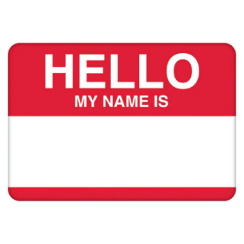
  - You are probably going to be the first person that someone sees when they walk into your store; make a unforgettable first impression, this sets the tone for the rest of their experience.
2. Greet them
  - Give your undivided attention to the customer- lets them know that they are the most important person to you at that time.
  - Pay attention to them, don’t get distracted by others, phones ringing, etc.
    - Ask them if they have any questions
    - Be a menu tour guide- walk them through the menu, know your menu items and where they are located on the physical menu and be able to answer questions if they have any.
    - Mustard, lettuce, tomato, pickles, onion okay on that?
    - Bacon is a little spicy, is that okay?!
3. Repeat the order back to them!
  - This ensures that you heard the order correctly and allows you to catch any mistakes or add any additional items to their order .
    - *If there is a large group and the others walk away leaving one person to pay, don’t waste time repeating the order back, that person isn’t going to know what everyone else got to eat.
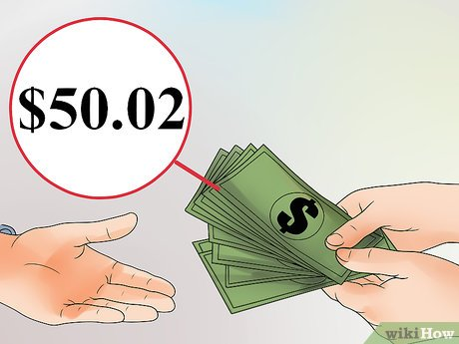
4. Count their change back to them to ensure they’re getting the proper amount back and so you can ensure that you are giving the proper amount back to them.
5. Give time expectations while promoting your server. What is a time expectation?
    - These are your ticket times, how long is it currently taking for people to get their food once their order is placed. If you are unsure about how to find the time expectations, ask your manager!
    - It’s important to let customers know time expectations so they don’t expect their food to be out in 5 minutes. WE ARENT FAST FOOD
    - Don’t forget to always introduce your guest service. That way if they need anything throughout their experience, they know who to go to.
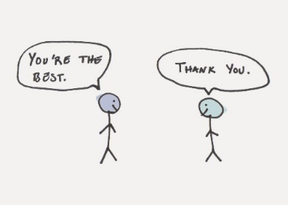
6. Thank You- always thank them. Welcome them back, be courteous and respectful towards them.
  - Educate-
    - Give further direction- “drinks are right over here {points to drink station} have a seat wherever you would like and when you hear your name called, you don’t have to get up, just raise your hand and “{insert name here} will bring your food out to you.
The cashier position sets the tone for getting the full “Grumps experience” the cashier is often the first person customers see and talk to when they walk in the door- make a great first impression, try to remember peoples’ names and recognize those who are regulars, people love a little recognition.
Ice Cream Shake/Scoop Video
Alcohol service
- Make sure that if someone is starting a tab at the register, that you get a card or ID to keep behind the counter. Be sure to teach the trainee how to start a tab and how our system works. Remember to always run hot food before cold beer, get your manager on duty to help you ring in and pour beer while you run food.
Watch Alcohol Pour Video
HOW TO POUR A BEER
Step 1:
- Grab a schooner out of the mug cooler
- Grab the tap handle at the base and pull open quickly to ensure proper gas/beer mixture
- Hold the glass under the faucet at a 45-degree angle
- Place the glass close under the top
Step 2:
- Keep the glass at a 45-degree angle
- Once the beer is almost touching the draft tap, bring the glass and turn it to an upright position
- Don’t overfill or over-pour beer or foam. Every ounce lost = $$ lost!
Step 3:
- Create a ½ inch to a ¾ inch of foam
- Do not let the tap touch the beer
- Do not allow it to overflow
Step 4:
- Close the tap quickly to cut off flow

TOGO ALCOHOL PROCEDURES:
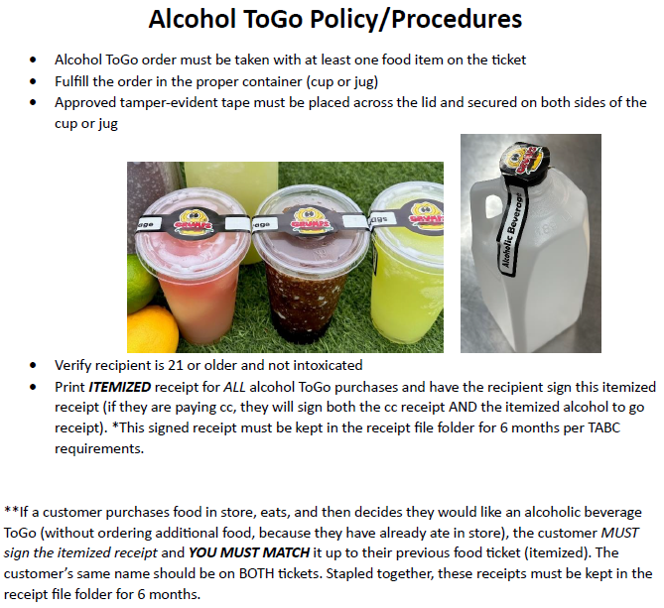
Sink Sanitation and Handwashing:
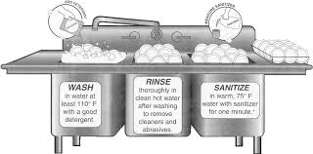
- Setting up the 3-compartment sink-
Wash: put soap in the sink with hot water.
Rinse: plain hot water to rinse off the dishes
Sanitize: put the appropriate amount of tablets of sanitizer in room temperature water, let them dissolve and it is good to go! PH level should be 200-400 PPM. Use test strip to test the water to ensure it is right.
Handwashing- It’s the easiest and most important tool we have. Make sure to wash your hands often. NEVER take your apron into the bathroom!!! Make sure if you go to the restroom or clean up a mess, you wash your hands. People pay attention to the smallest things and the last thing we want to have to deal with is lack of sanitation and handwashing.
WHAT TO DO WHEN YOU’RE READY TO GET CHECKED OUT BY A MANAGER:
- There will be a printed checklist for each position and specific times of day (opening, mid-day and closing) hung in your restaurant. On this checklist you will find the duties that you must complete before getting a manager to check over your work.
- Be sure that your entire checklist is done for that shift. Try not to wash dishes as the first thing you do because there’s going to be more dishes that are brought back while you are doing your cleaning duties. Set your guest service up for success. TEAMWORK!! You would want them to do it for you, so do it for them. *Customer line of sight*
Day Two:
Classroom: 10:00AM-10:30AM & POS Training: 10:30AM-11:00AM OR
Classroom: 3:00PM-3:30PM & POS Training: 3:30PM-4:00PM
ON THE JOB TRAINING
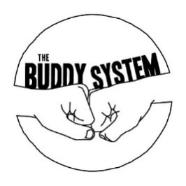
- During day 2 of training, the trainee should be actually touching the POS today if they didn’t on day 1. Be sure to utilize the 30 minutes of POS practice after their classroom to show them how to navigate the screen and how to modify items. The trainee will be ringing in the order while the trainer is asking the customer all the questions. Towards the end of the shift or just whenever the trainee feels comfortable, they can take over and ask the questions.
- The trainer should still never walk away from the counter to go wash dishes or start their cleaning lists without the trainee right there next to them. You know, the 5-foot rule we talked about…
- **If there is any downtime throughout the shift, be sure to show the trainee how to read kitchen chits. This could be through putting togo orders together or just grabbing the kitchen chits that have already been delivered and going over what is on them. **

Beverage Review:
Beer-Draft (Our schooners are ice cold and create ice in the beer after pouring it, please make sure you train properly on how to pour our beer)
Bottled beer- (bottles vary depending on the store)
Margaritas- Regular Frozen or On the Rocks or a Sangria Swirl Frozen Margarita
Southern Slushes- Frozen Burbon and Cola Slush
Sodas-Dublin Sodas
Tea’s- Sweet or unsweet tea
Milkshakes- Strawberry, Chocolate, Vanilla, Cookies n Cream.
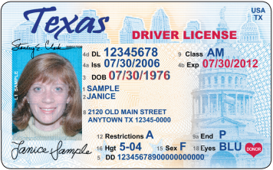
Responsible Alcohol Service:
- Please become familiar with the proper way to check ID’s and what to look for on those ID’s. (birth date/year, expiration date)
- Become certified with a TABC certificate to be able to handle and serve alcohol. If the store doesn’t have a copy of your TABC, YOU ARE NOT ALLOWED TO HANDLE/SERVE ANY FORM OF ALCOHOL!!! NO EXCEPTIONS!!!

Day Three (final day):
Classroom: 10:00AM-10:30AM & POS Training: 10:30AM-11:00AM OR
Classroom: 3:00PM-3:30PM & POS Training: 3:30PM-4:00PM
ON THE JOB TRAINING:
- Today is the trainee’s final day, by the end of today, your trainee should be able to do the following:
  - Know the Grumps Differentiators
  - Ring in orders and know the questions to ask while at the cashier counter
  - Make shakes and pour beer/margs/slushes
  - Know where the mid-day/closing check list is and what each item is on the checklist
  - Be able to take a Togo order on the phone and have the right phone etiquette
  - How to read tickets or at least have a brief idea of what shows up on the tickets
  - How to handle customer concerns and how to help them and to get a manager for help.
- **If there is any downtime throughout the shift, be sure to show the trainee how to read kitchen chits. This could be through putting togo orders together or just grabbing the kitchen chits that have already been delivered and going over what is on them.
WHAT TO DO WHEN TAKING A TOGO ORDER:
- When answering the phone, always answer the phone with a smile, people can hear that on the other end.
- Always mention your name and the name of the specific location you are working in to avoid confusion since we have multiple locations.
- Ask them what they would like, be sure to mention that all of the veggies and condiments come on the side, so they don’t have a soggy burger when they get home and to keep the veggies fresh.
- Many times, people forget to order the side, or they think the burgers come with one so be sure that we offer a specific side.
- Complete the order, educate your customers and let them know that sides and drinks are sold separately.
- At the end of the order, be sure to get their name for the order and ask them if they need any salt, pepper, ketchup or napkins in the bag so we can notate it on the receipt to ensure the customer gets what they need.
- GIVE THEM A TIME EXPECTATION!!!
- Explain that they can either do curbside pick-up or in store pick-up and explain the process for both.
Watch ToGo Phone Call Video
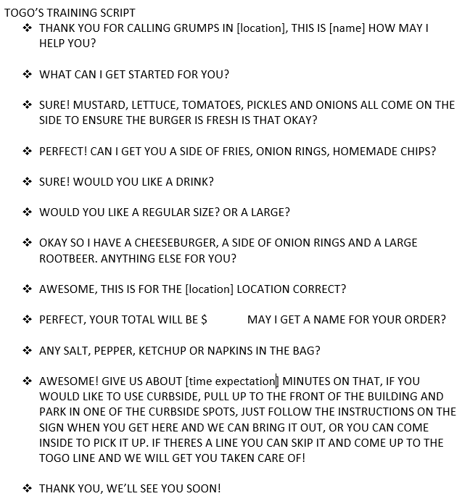
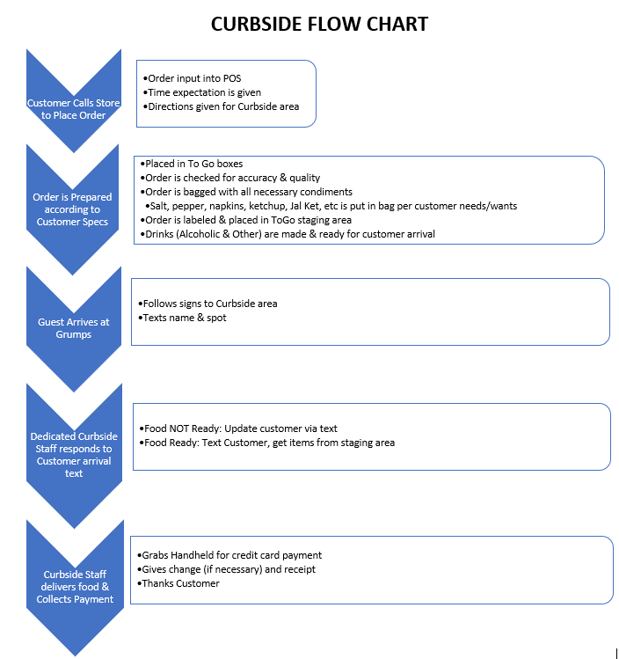

VOIDS/DISCOUNTS
- All discounts that are done must be accounted for and signed off by a manager. Please refer to the discounts page in the new hire paperwork to see who we give discounts to. When you are on the register, if you come across having to do a discount, you must print out the itemized receipt with the discount on it and get it signed by a manager then that paper must go into the designated area that discounts are kept. If something is needed to be voided off, YOU MUST GET THE MANAGER TO COME HELP YOU.
CUSTOMER CONCERNS:
The 3 A’s to handling customer complaints:
Acknowledge
Apologize
Act
- If a customer is upset with something, first off Acknowledge the problem. Get all the information you can to understand the issue. Second, Apologize for the problem. Third, Act. Get your manager involved. Never EVER be the bad guy, let management handle it but if you can fix it, then do it. It shows that you care. Fall on the sword and own up to the mistakes! Again, let a manager handle it if you can’t!!

GUEST SERVICE TRAINING

Day One:
Classroom- 9:00AM-10:00AM & OJT 10:00PM-4:00PM OR
Classroom: 3:00PM-4:00PM & OJT: 4:00PM-CLOSE
ON THE JOB TRAINING
- Today your trainee will be following next to you the whole shift. The trainee shouldn’t be touching much or doing much work throughout the shift just watching unless they are accelerated.
- Take your trainee on a tour of the restaurant, show them where everything is so they don’t have a million questions about where to find stuff.
- Cover the basics of the role of a Guest Service be sure to answer any questions your trainee might have throughout the shift.

Guest Service Duties and Responsibilities
- Opening, Mid-Day, & Closing Procedures
- Customer Interactions
- Cleaning & Restocking
- Side work
- Running TABS
- Pouring Alcohol
- Any other duties as requested by Manager on Duty

Grumps Differentiators:
We know our Grumps Differentiators work. They are proven to work! Your money is made out front and not by hiding in the back.
- INTRODUCE YOURSELF AND OFFER PEANUTS
- READ ORDER BACK AND PROPER DISTRIBUTION OF FOOD
- REFILLS
- TWO BITE RULE
- PRE-BUSSING
- OFFER/EDUCATE
- FULL HANDS IN FULL HANDS OUT
- THANKING CUSTOMER AT DEPARTURE
- BATHROOM CHECKS
- PROPER CLEANING AND BLOCKING OF TABLES
- PLEASE, THANK YOU, YOU’RE WELCOME

Guest Service Differentiator Video
- Introduce yourself and offer peanuts
  - You have your name on your shirt, but physically introduce yourself! “Hi, my name is {insert name here} I’ll be your server today! Would you like any peanuts to snack on?” This is also the perfect opportunity to offer highchairs and/or booster seats to the kiddos. Make them feel welcome and at home!
- Read order back and proper disbursing of food
  - Make sure to read off each item on the ticket and on the burger. Hand the appropriate side item (if applicable) with the burger as well. Make sure you hand the right item to the right person.
- Refills
  - Auto-refills. Instead of asking if they would like a refill, ask them “what-cha drinking? Let me grab you a refill”
- Two bite rule
  - After about 2 minutes of dropping off the food, or after the customer eats about 2 bites, follow up with the table and make sure everything is tasting okay. If this doesn’t happen and something is wrong with the food, it gives us the opportunity to make it right with the customer, and possibly keep the customer coming back. Keep up with your tables and make sure you are checking on everyone often.
- Pre-bussing
  - Become the pre-bus “queen/king” as soon as there is anything that could be taken off the table, remove it. There’s nothing worse than going out to eat and not having room to put things on the table because there’s a bunch of trash on the table, take it away!!
- Offer/educate
  - How would people know about our award-winning Jalapeno ketchup if we don’t offer them any?!
  - Educate about happy hour during non-happy hour times. “hey I see you’re drinking a beer, our happy hour is…”
- Full hands in, full hands out
  - Move with purpose. If you leave the kitchen with food, don’t come back to the kitchen empty handed. Always try to have something in your hands at all times to show that you are keeping busy.
- Thanking at customer departure
  - We appreciate every single person who walks through our doors. Make them feel welcome but when they leave, leave such an impression that they want to come back. We want people eating here from 2,3,4 times a month!! Build those regulars! We are in the customer service business.
- Bathroom checks
  - Make it a point to go into the bathrooms once or twice an hour and help keep up with the cleanliness of them. Don’t be lazy, if something needs to be cleaned up or changed (paper towels, toilet paper, etc.) do it! TEAMWORK!! If you are too busy or if there is an issue, get your manager to help you.
  - Make sure that when you do restroom checks that you take off your apron in the kitchen before going into the bathroom!
- Proper cleaning and blocking of tables
  - Clean all the items on the table with sanitizer! (Salt and pepper shakers, ketchup) also wipe down the chair seats and the handle on the chair, highchairs, boosters, etc. Re-block the table after customers get up so your manager/co-workers know that table has been cleaned.
- Please, thank you, you’re welcome
  - Be courteous, kind and respectful. Use nice words to people because that will make the world of a difference and keep those people coming back.
Points of Contact:
- Points of Contact – You need to “touch” each table 4 times during their visit. There are exceptions for tables who guzzle drinks, have children, drink beer, etc… you be the judge, but don’t bombard guests with “too much” service. Always be kind & helpful (Use “Please, Thank You, You’re Welcome”)

  - Point of Contact 1: Introduce yourself & offer Peanuts As soon as you notice a customer sit down at a clean table, welcome them & ask how they are doing. Offer them peanuts & introduce yourself using your name to establish the first point of contact.

  - When you hear “Order Up!,” the food is ready. Be sure to check the order against the ticket before it leaves the kitchen – put any condiments on the tray if they are called for. Full hands in, full hands out when entering/leaving the kitchen – move with purpose.

  - Point of Contact 2: Delivering the order:
Deliver food ASAP – Hot Food Before Cold Brews - Food first, drinks & beer 2nd ! This is your opportunity to interact with the customer. When coming up to the table, re-verify the name on the ticket before handing food out. Read order back & properly disburse food: Hand the food out item by item while reading the tickets off of the order (there is less chance that the wrong customer is getting that order). Be sure you are friendly & smiling and don’t seem rushed (even though you may be at times). Offer Jalapeno Ketchup with their meal. Offer drink refills at this time.

  - Point of Contact 3: 2-Bite Rule
Check back with your table after they have taken 2 bites of their meal – ensure that everything came out ok, deliver the Jalapeno Ketchup or Refills if requested

  - Point of Contact 4: Pre-Bus Table/Refill Drinks
As you are walking through the dining room & notice empty trays or trash sitting on the table and it looks like the customer is done eating, say “May I get some of this trash out of your way or I can take that” (or something along these lines) to remove the trash from the table. It gets it out of their way and leaves less to clean up once they are gone. Offer to refill their drinks for the ride out. This is also a subtle way to get them up & moving if you need table space. When they exit the restaurant, Thank Them Upon Departure.
Ketchup Bottle Prep Video
Ranch Prep Video

Day Two:
Classroom- 9:00AM-10:00AM & OJT 10:00PM-4:00PM OR
Classroom: 3:00PM-4:00PM & OJT: 4:00PM-CLOSE
ON THE JOB TRAINING
- Today the trainee will be still following but actually calling out and handing out orders. The trainer will still need to be within 5 feet of the trainee at all times and helping them with the delivery process. Please make sure to never leave your trainee in case someone has questions the trainee might not be able to answer yet.
- Introduce yourself and your trainee to every table, this lets people know that we are training and tends to make people a little more lenient and understanding.
- Show the trainee how to perform closing duties and count tips (NOT IN PUBLIC). Once y’all are done with closing duties, show the trainee how to get checked out by a manager before y’all leave.
- Trainee’s do not collect tips since they are getting paid more hourly than the server. If a customer hands a tip directly to the trainee that tip is to be put in the tip bucket.
To Go Process Video
Checking Accuracy Video
Areas of responsibility
- Customers
  - Hot food fast… before cold beer…
  - Pre bussing
  - Refilling
  - Check backs
- Dining areas
  - blocking tables
  - sanitizing chairs and tables
  - spot sweeping
- Dishes
  - Make sure to finish off any of the dishes from the end of the night or mid-day that you have accumulated after the cashier left.
- Bathrooms
  - Check bathrooms at least every hour to ensure they are clean and restocked. Wipe down heavy touching points (sink, mirror, door handles, baby changing station etc.)
- Drink station
  - Keep area wiped down around the soda machine and tea urns. Restock lids and straws
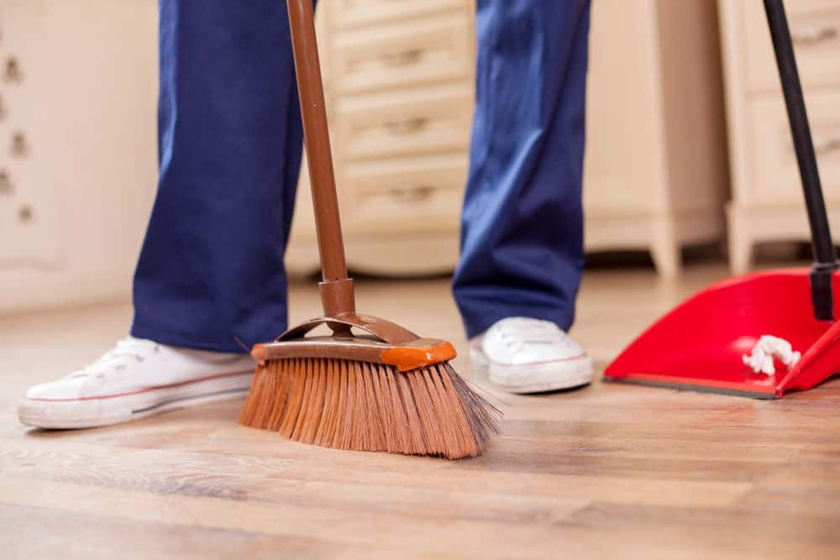
- Floors
  - Spot sweep throughout the shift to make it easier on yourself later in the night when you have to sweep the whole place. Always stay 1 step ahead.
  - If you need to sweep a mess around a customer, be sure to communicate with them that you are about to clean up a mess and make sure they are okay with it.
- Sani bottles
  - Change out during the day to keep them fresh
  - Get sanitizer from the 3-compartment sink, don’t put sanitizer tabs in the bottle!

- Cleaning lists
  - Time to lean, time to clean
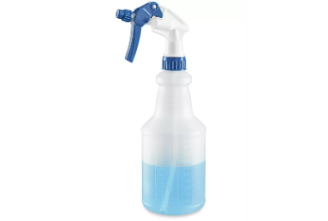
  - Clean during downtime, you should always be doing something constructive
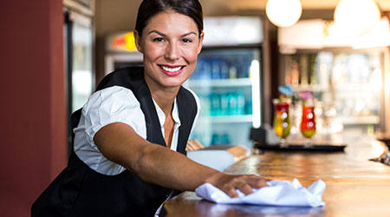

- Remember: Check backs
- Read the room- if you see a table that starts to look around like they’re getting impatient, walk up to the table and check on them. If they say they have been waiting a while, go to the kitchen and see how long their ticket has been hanging up. Get an estimated time of how much longer it will be and GO BACK TO THE TABLE and Let them know how much longer it will be. If they look like they are upset about it let the manager know so they can handle it.
- Remember: Introduce yourself
- Create the 15 second relationship. No longer than 15 seconds. Don’t get tied down but introduce yourself and create conversation. Make them want to come back to see you! Have some fun- spark a conversation with them, ask them about their day, compliment their shirt they are wearing, etc.
- Remember: Food running
  - When delivering food, be sure to call out the name on the ticket loud and proud to where people can actually hear you especially in high volume peak times when there are a lot of people in the restaurant.
Ticket reading- show examples of tickets and what to look for and how to read them.
Let people know about upcoming events (if applicable)… ie. Grumptoberfest, Mardi Grumps, etc…


Day Three (final day):
Classroom- 9:00AM-10:00AM & OJT 10:00PM-4:00PM OR
Classroom: 3:00PM-4:00PM & OJT: 4:00PM-CLOSE

Recap/questions

Areas of opportunity

ON THE JOB TRAINING
Today is the final day of training. Today the trainee will deliver all food orders, start and close tabs and help answer the phone.
Be sure that you as a trainer, still stay within those 5 feet of each other so that they still have ongoing support if they need it.
Remember that trainees are still not getting tips since they are getting paid more hourly. Make sure to work on any closing duties that is required and check out with the manager before you leave. Answer any last-minute questions the trainee might have over any aspects of training. Get with the manager on duty for the trainee to find out what their next week’s schedule looks like.

Other important info:
- Getting ready for the crowd and getting & rid of the crowd
  - Always make sure that you are set up for success for the whole shift. Check your prepped items and make sure you have enough on hand. Throughout the shift, pre buss as much as possible off the table. It shows the customers that they should start wrapping it up and heading out. Stay on top of your tables, you don’t want people sitting there all night!! The more tables that sit down, the mo green in yo jeans!!

- Getting your bank
  - At the beginning of each shift, your manager will put your bank in your tip bucket. This is for when people start tabs and pay in cash, so you have change to hand out to them. At the end of the shift make sure to give your bank back to the manager on duty. The rest of the cash is yours!
- Stay busy
  - In down time, be sure to spot sweep, work on prep if needed, and look over the weekly cleaning lists. If you have any questions about items on the weekly cleaning lists, be sure to ask a manager for clarification.
- Alcohol service
  - Make sure that if someone is starting a tab at their table, that you get a card or ID to keep behind the counter. Be sure to teach the trainee how to start a tab and how our system works. Remember to always run hot food before cold beer, get your manager on duty to help you ring in and pour beer while you run food.

Trainer- get with manager to discuss evaluation of trainee

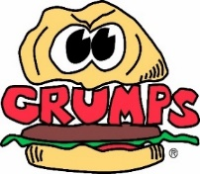
Trainee Name ______________________
Trainer Name ______________________
Trainee On a scale of 1-10 (10 being the highest) please circle one, all apply on some level. If it was not covered, please circle a 1.
How well did they listen to instructions?
Not good Average Very Good
1 2 3 4 5 6 7 8 9 10
Did they retain their training?
Not good Average Very Good
1 2 3 4 5 6 7 8 9 10
How was their personality with customers? Do they have a positive attitude?
Not Good Average Very Good
1 2 3 4 5 6 7 8 9 10
How comfortable did they seem?
Not Good Average Very Good
1 2 3 4 5 6 7 8 9 10
How well do they know their menu?
Not Good Average Very Good
1 2 3 4 5 6 7 8 9 10
How well do they know their Grumps Differentiators?
Not Good Average Very Good
1 2 3 4 5 6 7 8 9 10
What did you as a trainer see that your trainee was really great at? _____________________________________________________________________________________________
_____________________________________________________________________________________________
What are a few things that they need to work on? ________________________________________________________________________________________________________
________________________________________________________________________________________________________
Manager comments______________________________________________________________________________________
________________________________________________________________________________________________________

Manager Signature _______________________________________

