What to Bring on Your First Day:
- Identifying information as Required by the I-9 form
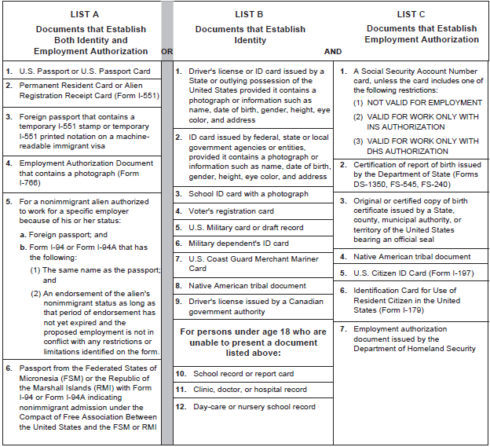

- Copy of Food Handler Certification (required for BOH & FOH)
https://www.360training.com/course/ansi-food-handler-training

- Copy of Food Manager Certification (required for Mgmt, Team Lead, Key)
https://www.360training.com/course/texas-food-safety-manager-principles-training-and-exam

- Copy of TABC Server Certification (FOH only) –Below is a suggested course:
https://www.360training.com/course/tabc-seller-server-training

You can find other TABC course links at https://www.tabc.texas.gov/services/tabc-certification/tabc-certification-schools/

